4.5. Structural Robustness of Disease-Associated Spectral Redistribution Using Experimental Basis Spectra
To test whether the predicted disease-associated spectral redistribution depended on idealized analytic line shapes, the visible oxidative-emission channels were replaced with experimentally measured ultraweak-photon-emission basis spectra digitized from Tsuchida and Kobayashi [37]. The empirical spectral templates represent linoleic acid, elastin, phospholipids, and linolenic acid measured over the visible range. Because complete experimental line-shape arrays were not available for the singlet-oxygen channels, the 634-, 703-, and 1270-nm singlet-oxygen-related components were retained as literature-anchored analytic profiles. The resulting hybrid representation therefore provides a stronger experimental spectral constraint while preserving the established near-infrared channels of the original model.
The empirical-basis model preserved the same healthy < severe COVID-19 < sepsis ordering observed with the Voigt, Gaussian, and log-normal representations (Table 5; Figure 9). The spectral centroid increased from 552.03 nm in the healthy condition to 589.52 nm for severe COVID-19 and 607.27 nm for sepsis. These values corresponded to disease-minus-healthy centroid displacements of 37.49 nm and 55.24 nm, respectively (Table 6; Figure 8A). Although these displacements were smaller than the approximately 44-45 nm COVID-19 and 65 nm sepsis changes generated by the three analytic line-shape models, their signs and disease ordering were unchanged.
The red-to-blue photon-yield ratio showed the same behavior. Under the Tsuchida empirical hybrid, the ratio increased from 0.399 in the healthy condition to 0.715 for severe COVID-19 and 0.901 for sepsis (Table 5). Relative to healthy conditions, the corresponding increases were 0.316 and 0.502 (Table 6; Figure 8B). These increments were somewhat larger than those predicted by the analytic models, indicating that the experimentally measured visible spectral shapes modify the quantitative partitioning of emitted photons while preserving the direction of the disease-associated redistribution.
When all four spectral structures were compared, the principal qualitative result remained unchanged: increasing modeled oxidative burden produced a larger relative contribution from longer-wavelength emission channels. The empirical-basis analysis therefore strengthens the conclusion that the predicted redistribution is not an artifact of selecting a Gaussian, log-normal, or Voigt profile. At the same time, the absolute centroids and red-to-blue ratios remain conditional on the external spectral templates, emitter abundances, channel weighting, and the retained analytic representation of singlet-oxygen bands. The Tsuchida spectra were obtained under UVA-induced oxidation of skin-related biomolecules rather than from infection-associated samples and should therefore be interpreted as external experimental molecular priors, not as disease-specific spectral measurements.
Taken together, the empirical-basis analysis provides an additional level of structural support for the spectral prediction. The disease-associated direction of centroid displacement and red-to-blue enhancement survives replacement of the visible analytic channels with experimentally measured biomolecular spectra, whereas the quantitative magnitude of the redistribution remains model dependent. This distinction supports interpretation of the spectral result as a mechanistically constrained, hypothesis-generating prediction of altered oxidative-emitter composition rather than as a validated COVID-19 or sepsis spectral biomarker.
Table 5. Spectral centroid and red-to-blue photon-yield ratio across analytic and experimentally constrained spectral representations.
Spectral model | Condition | Centroid (nm) | Red-to-blue ratio | Peak wavelength (nm)
Voigt | Healthy | 523.13 | 0.191 | 479.5
Voigt | COVID-19 | 567.77 | 0.444 | 484.5
Voigt | Sepsis | 588.09 | 0.595 | 633.5
Gaussian | Healthy | 516.47 | 0.183 | 484.5
Gaussian | COVID-19 | 561.47 | 0.443 | 488.0
Gaussian | Sepsis | 582.16 | 0.597 | 633.5
Log-normal | Healthy | 526.15 | 0.221 | 486.0
Log-normal | COVID-19 | 570.59 | 0.499 | 490.0
Log-normal | Sepsis | 590.75 | 0.662 | 633.5
Tsuchida empirical hybrid | Healthy | 552.03 | 0.399 | 490.0
Tsuchida empirical hybrid | COVID-19 | 589.52 | 0.715 | 633.5
Tsuchida empirical hybrid | Sepsis | 607.27 | 0.901 | 633.5
Table 6. Disease-associated spectral redistribution relative to the healthy condition.
Spectral model | COVID Δ centroid (nm) | Sepsis Δ centroid (nm) | COVID Δ red/blue | Sepsis Δ red/blue
Voigt | 44.63 | 64.96 | 0.253 | 0.404
Gaussian | 45.00 | 65.69 | 0.260 | 0.414
Log-normal | 44.45 | 64.61 | 0.278 | 0.441
Tsuchida empirical hybrid | 37.49 | 55.24 | 0.316 | 0.502
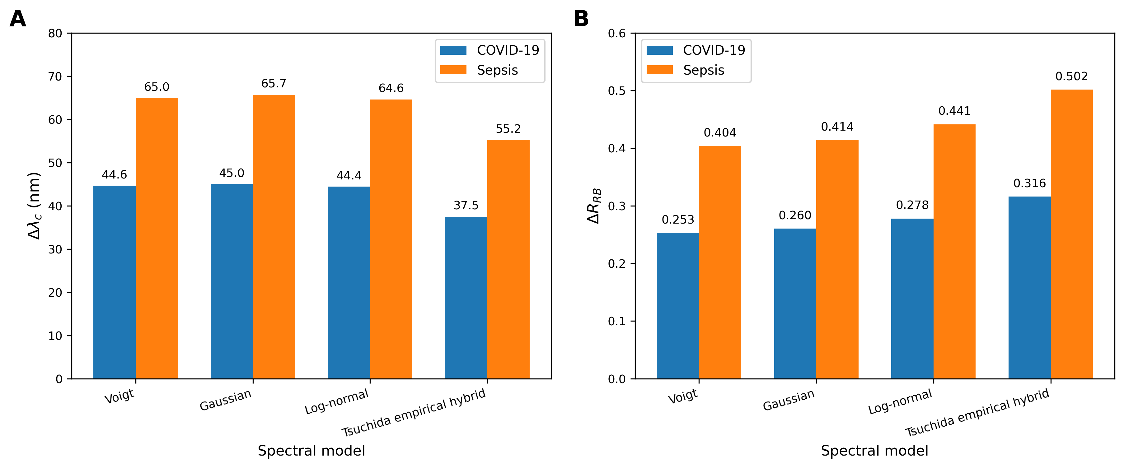
Figure 8. Structural robustness of disease-associated spectral redistribution relative to the healthy condition. (A) Change in spectral centroid (Δλc) for severe COVID-19 and sepsis under Voigt, Gaussian, log-normal, and Tsuchida empirical-hybrid representations. (B) Corresponding change in the red-to-blue photon-yield ratio (ΔRRB). All four models preserve positive disease-associated redistribution, while the exact magnitude remains dependent on the spectral representation.
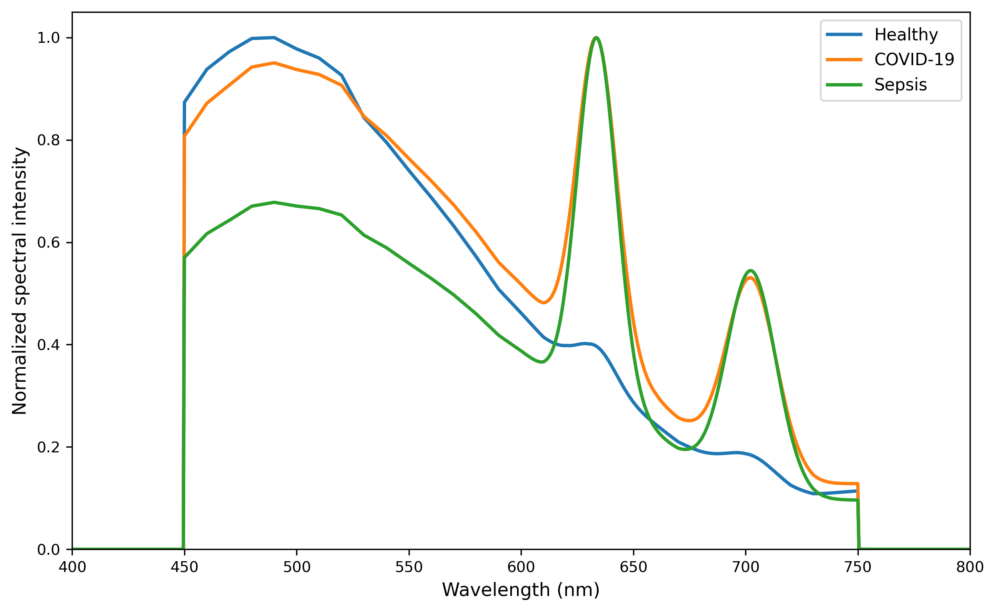
Figure 9. Disease-associated spectra generated with the Tsuchida empirical-hybrid representation. Digitized experimental visible UPE basis spectra from Tsuchida and Kobayashi [37] were used for the visible oxidative-emission channels, while literature-anchored analytic profiles were retained for the singlet-oxygen-related channels. The model preserves the healthy < severe COVID-19 < sepsis ordering and predicts progressively greater relative contribution from longer-wavelength emission channels.

